Stacks And Queues

**Check for Balanced Parentheses:**

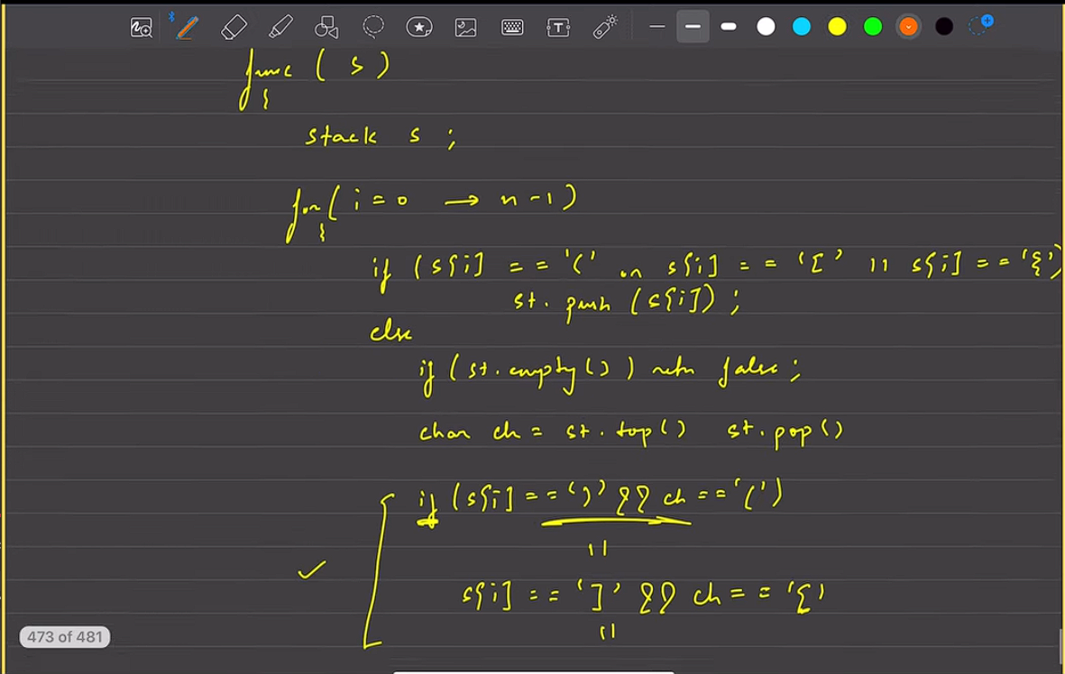

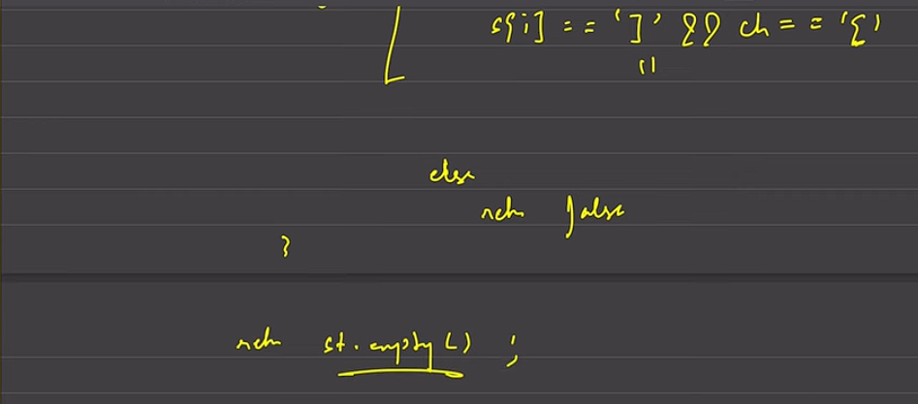

TC and SC :- O(n)